Chlamydia trachomatis is an obligate intracellular organism that is responsible for one of the most common bacterial STI’s reported worldwide (>100 million cases are documented worldwide per year), and it is further classified into 15 serovars: Serovars A-C are accountable for trachoma, the most common cause of bacterial induced vision loss in underdeveloped countries, serovars D-K are accountable for infection of the genital mucosa, and serovars L1-L2 are accountable for lymphogranuloma venereum (1). Even though the disease can be asymptomatic, it is still capable of causing tissue damage within the reproductive tract that leads to infertility and ectopic pregnancies in women. Recurrence and persistence of infection has also been linked to the development of cervical and ovarian cancers (2). No vaccines are currently available.
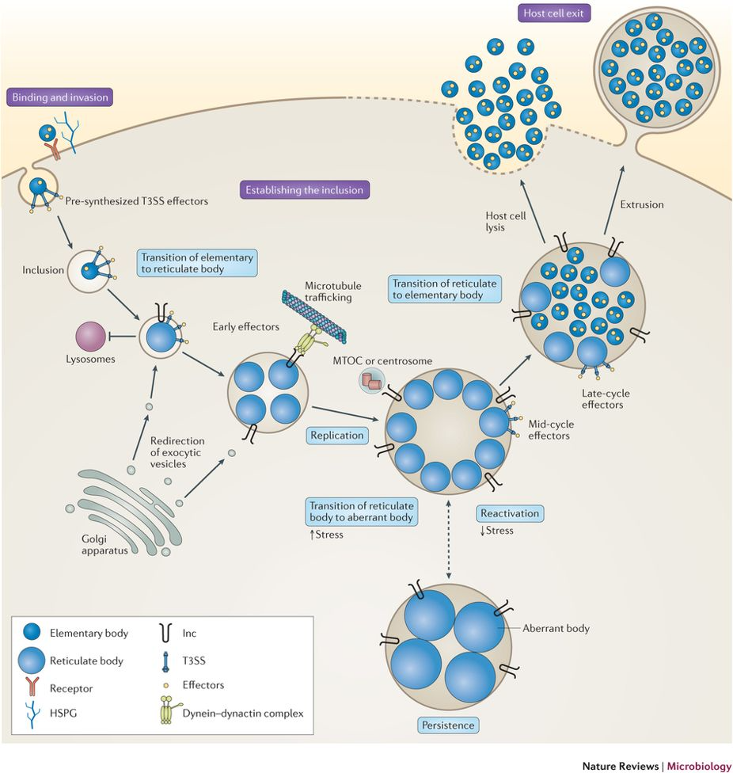
Fig. 1- Developmental Cycle of Chlamydia spp. (3)

Chlamydia spp. have a unique developmental cycle that involves infection of epithelial cells, hijacking of host cell components, and the transition between two forms of the bacteria over a course of 48-72 hours depending on the species: extracellular elementary bodies (EBs) and intracellular elementary bodies (EBs) (4). EBs are the infectious, non-metabolically active form, while RBs are the replicatory, noninfectious, metabolically active form. After 48-72 hours, the EBs exit the host cell either by lysis or a mechanism known as inclusion extrusion. From this point, the cycle continues.

References

1. Schachter, J. (1999). Chlamydia: Intracellular Biology, Pathogenesis, and Immunity, Chapter 6, ed
R. S. Stephens (Washington, DC: ASM Press), 139–170.

2. Das, M. (2018). Chlamydial infection and ovarian cancer risk. Lancet Oncol 19(7):e338. doi: 10.1016/S1470-2045(18)30421-2.

3. Elwell, C., K. Mirrashidi, and J. Engel. (2016). Chlamydia cell biology and pathogenesis. Nat Rev Microbiol 14(6):385-400. doi: 10.1038/nrmicro.2016.30

4. Moulder, J. W. (1991). Interaction of chlamydiae and host cells in vitro. Microbiol Rev 55(1):143-190.

